Casino: Taxonomy Profile
Taxonomy Factor | Classification
Name | Online casino (real-money): slots, roulette, blackjack, baccarat, live-dealer tables and crash games. Profiled as a class rather than a single brand
Candidate Class | Offshore/unlicensed bookmakers and casinos (T6 in Australia); licensed online casino (T5) in jurisdictions that license it
Primary Audience | Adults 18+ in principle. Unlicensed operators sit outside Australian consumer-protection rules, and lookalike branding is used to reach local players
Gambling Connection | Direct. Real money is staked on chance-based casino games with a cash payout
Addiction / Harm Score | 9/10: Very High
Risk Score | 8/10: High
Tier Classification | T6 in Australia (unlicensed and prohibited). T5 where the operator holds a recognised local licence
Financial Score | 9/10: Very High
Monetary Value | Real cash deposited, converted to credits or chips and withdrawable as cash, subject to operator terms
Regulatory Status | Prohibited interactive gambling services are unlawful in Australia under the Interactive Gambling Act 2001 (Cth), and ACMA (2026) had blocked 1,788 illegal gambling and affiliate sites by August 2026. The service is lawful only where the operator holds a local licence.

1. Casino
Online casino websites and applications provide real-money casino games (slots, roulette, blackjack, baccarat, live-dealer tables and crash games). This profile does not consider them as a brand per se, but as a class. Unlike the retail or free-to-play apps from the previous profiles, their primary role is gambling.

2. Description and Connection to Gambling
Online casinos provide players with the ability to deposit money, then convert it to credits or chips, and play chance-based games like slots, roulette, blackjack, and live-dealer tables for a cash payout. These are interactive gambling services which are prohibited in Australia. The ACMA lists online casinos, online slot machines and in-play sports betting as prohibited, and the Interactive Gambling Act 2001 (Cth) is the operative law (ACMA, n.d.; Interactive Gambling Act 2001).
Enforcement involves issuing warnings and blocking websites. By August 2026, the ACMA had blocked 1,788 illegal gambling and affiliate sites, and more than 230 illegal services had withdrawn from the Australian market (ACMA, 2026). In 2025, ACMA’s warnings reached operators from Curaçao, the Netherlands and the Comoros (Public Gaming Research Institute, 2025). The chip-and-credit design that conceals the loss is behind the casino model, and pilot evidence indicates that gamblers bet larger amounts when they play with chips as opposed to comparable amounts of cash (Lapuz & Griffiths, 2010).
Gambling Connection: Direct. Real money is staked, and real money can be paid out.

3. Age Group and Addiction Risk
The primary age group for the profile will be adults (18+). There are some sites that do not have a licence and are not under Australian rules, and ACMA cautions that while these may appear legitimate, they are unlikely to have key consumer protections (ACMA, 2024). Lookalike brands, aggressive marketing, and the blocking of two imitation sites in November 2025 by the ACMA that posed as licensed Australian operators are what offshore operators are using (iGamingToday, 2025).
Addiction / Harm Score: 9/10 = Very High. The score is for direct cash at risk, round-the-clock access, and continuous-play games. It is higher than any social-casino profile, as a real monetary loss occurs after each round where you lose. Evidence on scale:
- In 2011, a survey of a sample of online gamblers in Australia found that a large percentage of respondents were frequenting online gambling venues that were outside Australia, such as casino and poker websites, which the authors interpreted as evidence that the ban was not actually deterring online gambling. The sample was self-selected (Gainsbury et al., 2011).
- Gainsbury (2014) quoted a government estimate that some 60% of Australian expenditure on interactive gambling was on prohibited gambling services overseas in 2010. The figure is outdated and should be treated only as an indication.
This is an assessment of a taxonomy, and not a clinical diagnosis. Both numbers are based on information over 10 years old and refer to offshore spending in general, not current spending on casino sites.

4. Risk or Danger
Risk Level: High: 8/10. Other jurisdictions' licensed operators are part of the class, which accounts for the lower score compared to Melbet's.
No recourse: The illegal operators are beyond Australian complaints and protection mechanisms, and even well-designed websites are unlikely to offer protections such as ACMA (ACMA, 2024).
- Imitation sites. The sites have been blocked, despite claiming to be licensed Australian operators (iGamingToday, 2025).
- Blocked sites reappear. It's a list of blocked sites that continues to grow as sites are blocked through enforcement. The reference point is the public list of blocked sites by the ACMA (n.d.).
- A licence is not a form of protection. A licence from an offshore regulator is not an Australian licence and is not as stringent as the licences of stricter regulators (see Melbet's profile).

5. Tier Classification
Tier: T6 in Australia; T5 where licensed.
Classification path (Australia):
Online casino → cash deposit → chips or credits → real-money slots and tables → cash withdrawal → no Australian licence, prohibited service → T6
Classification path (licensed jurisdiction):
Same product → operator holds a recognised local licence → T5
Note for the taxonomy: the same product changes tier with jurisdiction. This is the strongest evidence for adding a jurisdiction facet to the game-and-role pair.

6. Harm: Financial Harm and Psychological Harm
Financial Score: 9/10: Very High
Financial harm. Deposits are lost to house edge in play, and where the operator is unlicensed a player who wins may face refused or delayed payment with no dispute route (ACMA, 2024). Langham et al. (2016) list financial harm first among seven categories, alongside relationship, emotional or psychological, health, work or study, criminal acts and cultural harm.
Psychological harm. Emotional and psychological harm is another of the seven categories, and Langham et al. (2016) found harm is not confined to people who meet diagnostic criteria. The same categories apply here, with the added stress of dealing with an operator outside any complaint scheme.

7. Monetary Value
Monetary Value: Real cash in, real cash out
Cash-out pathways:
- Direct cash-out: deposit → chips or credits → play → withdrawal to the player's payment method, subject to the operator's terms and verification.
- Regulatory status changes the pathway's reliability: licensed operators are subject to complaint processes, whereas unlicensed operators are not (ACMA, 2024).

8. Evidence as Images
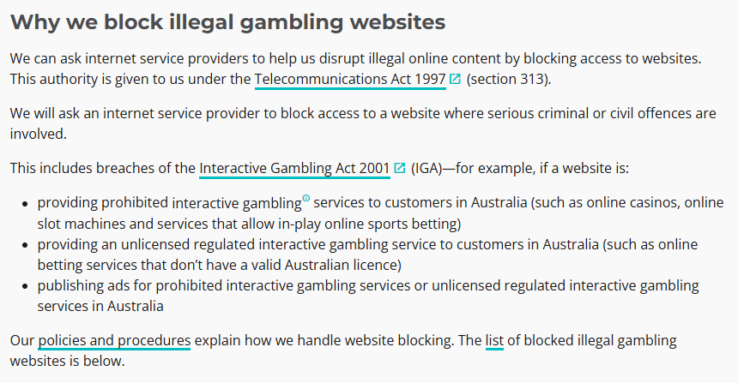 | 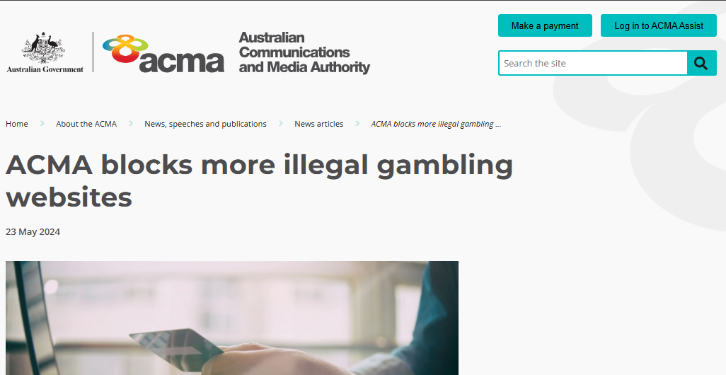
Figure 13: ACMA page explaining why illegal gambling websites are blocked, listing prohibited services | Figure 14: ACMA news article "ACMA blocks more illegal gambling websites" (23 May 2024)
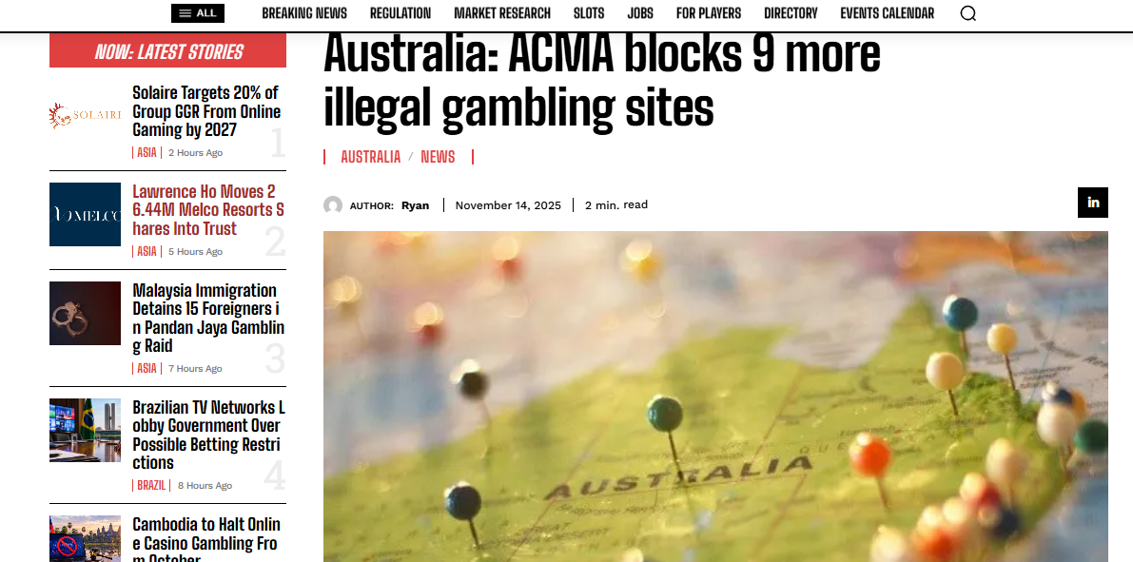 | 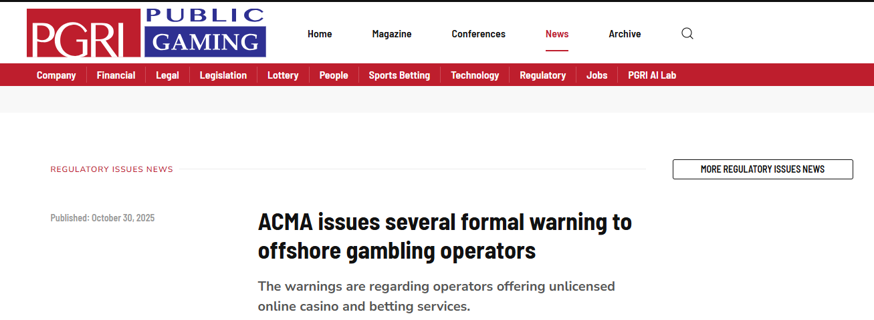
Figure 15: iGamingToday: sites blocked and imitation sites | Figure 16: Public Gaming Research Institute report on ACMA formal warnings to offshore operators (30 October 2025)

9. References
Australian Communications and Media Authority. (2024, May). ACMA blocks more illegal gambling websites. https://www.acma.gov.au/articles/2024-05/acma-blocks-more-illegal-gambling-websites
Australian Communications and Media Authority. (2026, August). Latest illegal online gambling websites blocked. https://www.acma.gov.au/articles/2026-08/latest-illegal-online-gambling-websites-blocked
Australian Communications and Media Authority. (n.d.). Blocked gambling websites. Retrieved 21 September 2026, from https://www.acma.gov.au/blocked-gambling-websites
Gainsbury, S. (2014). Interactive gambling (AGRC Discussion Paper No. 3). Australian Institute of Family Studies. https://apo.org.au/sites/default/files/resource-files/2014-11/apo-nid42431.pdf
Gainsbury, S., Hing, N., Blaszczynski, A., & Wood, R. (2011). An investigation of Internet gambling in Australia. Southern Cross University, Centre for Gambling Education & Research.
iGamingToday. (2025, November 14). Australia: ACMA blocks 9 more illegal gambling sites. https://www.igamingtoday.com/australia-acma-blocks-9-more-illegal-gambling-sites/
Interactive Gambling Act 2001 (Cth). https://www.legislation.gov.au/C2004A00851
Langham, E., Thorne, H., Browne, M., Donaldson, P., Rose, J., & Rockloff, M. (2016). Understanding gambling related harm: A proposed definition, conceptual framework, and taxonomy of harms. BMC Public Health, 16, Article 80. https://doi.org/10.1186/s12889-016-2747-0
Lapuz, J., & Griffiths, M. D. (2010). The role of chips in poker gambling: An empirical pilot study. Gambling Research, 22(1), 34–39.
Public Gaming Research Institute. (2025). ACMA issues several formal warning to offshore gambling operators. https://publicgaming.com/news-categories/regulatory-issues/15055-acma-issues-several-formal-warning-to-offshore-gambling-operators

